1. Get the list of nodes in cluster

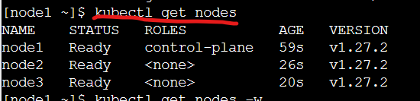

1. Watch the changes in the nodes

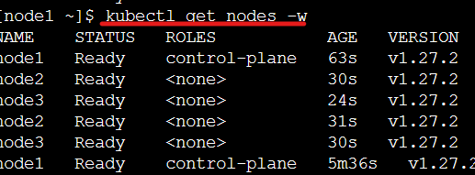

1. List of api-resources

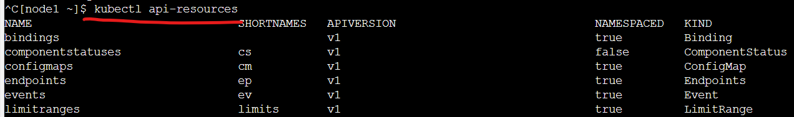

1. Create an alpine pod
2. ---
3. apiVersion: v1
4. kind: Pod
5. metadata:
6. name: alpine
7. spec:
8. containers:
9. - name: alpine
10. image: alpine
11. args:
12. - sleep
13. - 1d

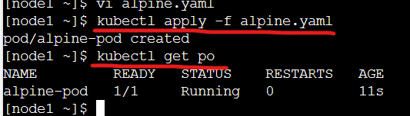

5.To execute commands in container

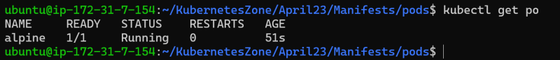

6. To get into containers

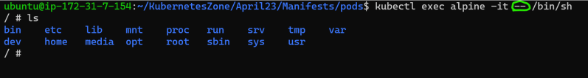

7. see the labels of the pods

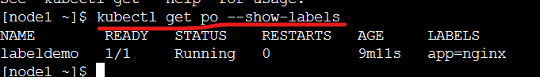

8. To filter a pod with specific labels

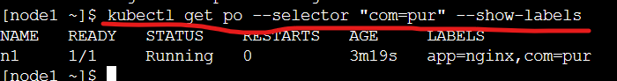

9.